TP 02

How to use commit , savepoint and Rollback

**Supervised by:**

**Phd Ouared abdelkader**

**Presented by:**

**Lebani Ali Zakaria**

**Rahlaoui Lahcen**

**Laoumir Mustapha Abdelkader**

Exercice 01 :

The expected results in this query are:

* Part one

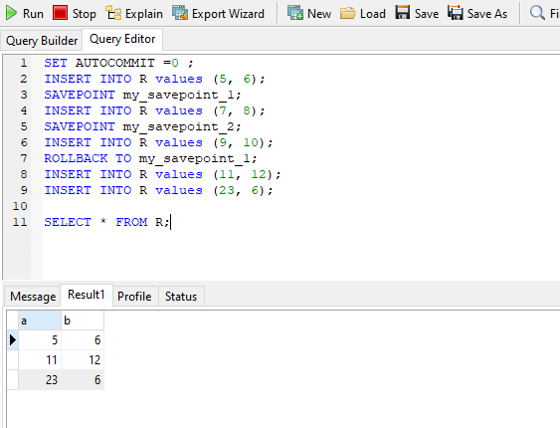

* Part two

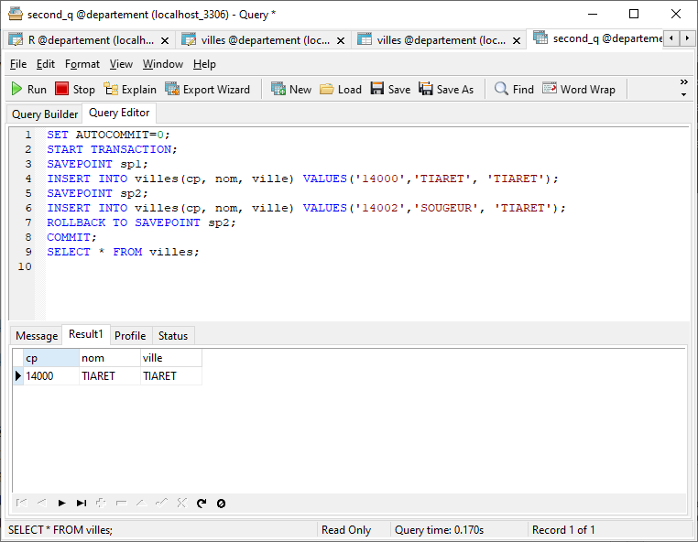

**Conclusion :**

* ‘ Set autocommit = 0 ‘ For disabling the autocommit mode and start the transaction for safe work .
* Specify the savepoint ‘ my_savepoint_1 and my_savepoint_2 ’ in the first image and ‘ sp1 and sp2 ’ in the second image , this savepoints for saving the work in a specific moment and come back to this point when something gets wrong happens.
* We have used the ‘INSERT INTO’ to test those savepoints.
* Then when we write the ‘ ROLLBACK ’ keyword for go to a specific savepoint for backup the old data .